Date: 2012.06.25
User Request: To generate manual invoice without scan pack process in WMS.

Proposed Solution:
After considering the request, it’s possible to work out on generate manual invoicing orders without scan-pack,
However this should be a separate order creation screen from current orders processing.

Below propose screen combining Orders creation with Package information:

List of changes and new information:

- Add new field Manual Order flag – a check box to indicate it’s manual invoicing , without scan-pack
- Enter COO at Order detail level.
- Add packages manually. (** Note that the package has no linkage to pack/order items in system)
- New generate Invoice button
- Shipping Label is not available for manual invoicing orders. Because system not able to link the pack item/ apof#.
Eddie: item 5, Shipping label - can it have a template for manual updating in system.
PF: to add Apof# and COO fields for manual input
- Generate new set of Invoice and Packing list print out.

Please review if you have any other concerns.

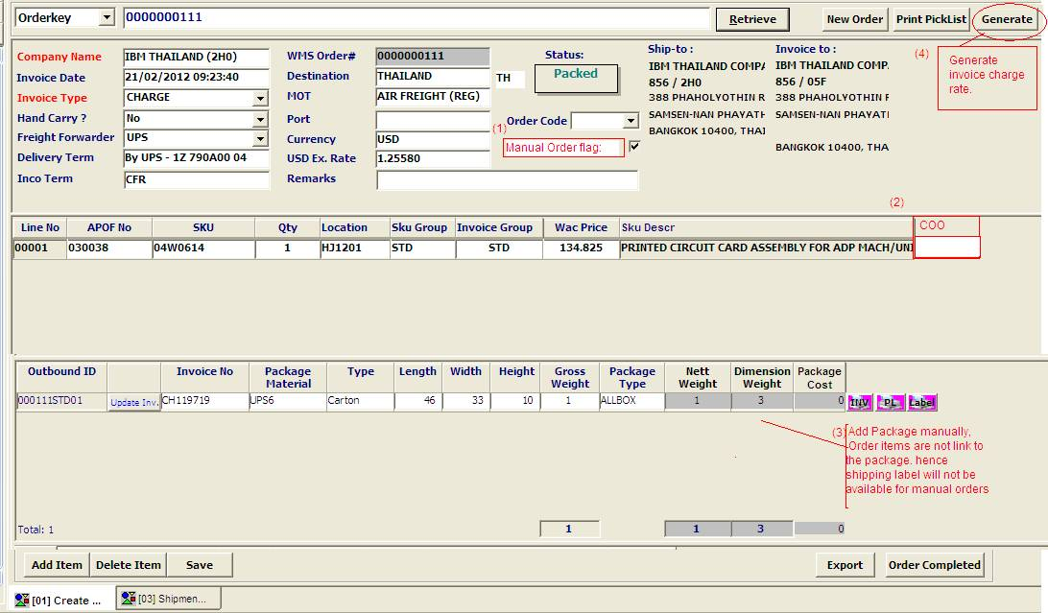

[2012.07.11]
Changes completed:

New Manual Orders invoicing screen:

[3. Outbound] →[M] Manual Invoice

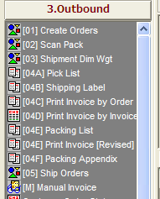

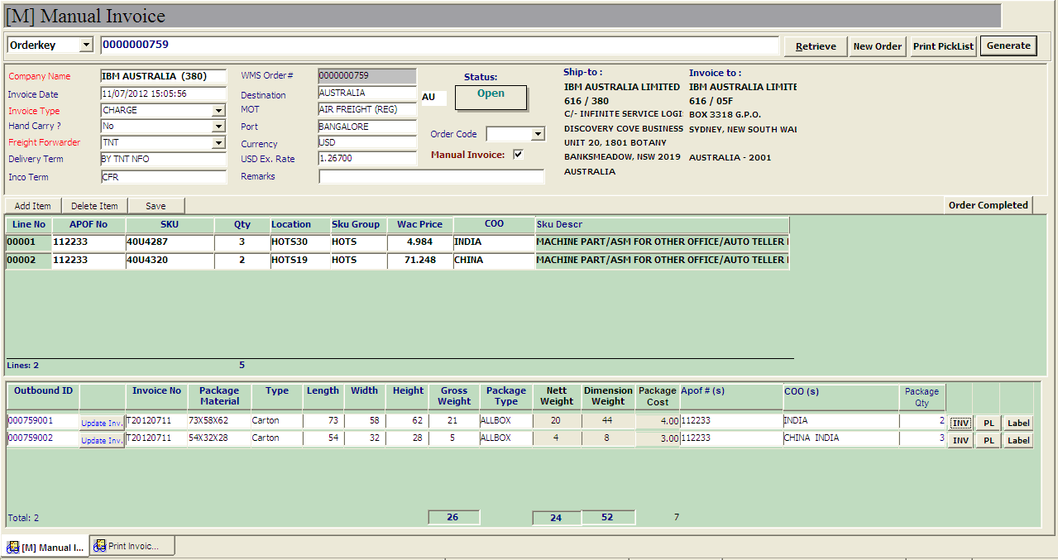
Order line detail:
Click to [add Item] to insert new lines detail.
Shipping label detail:
- Manual input APof# and COO for label printing
Generate Invoice:
[Generate] – to calculate freight charges.
Package detail:
Right click menu, select [Add] to add new package detail.

